

Upper Rogue River Canyon Roadless Area (and Rough Rider Falls)
Rogue River-Siskiyou National Forest--High Cascades Ranger District

The highest elevation portion of the (47 mile total) Upper Rogue River Trail #1034 is a little visited, but spectacular portion of trail paralleling the Rogue River, originating in the northwest corner of Crater Lake National Park in a 2,388 acre roadless extension.

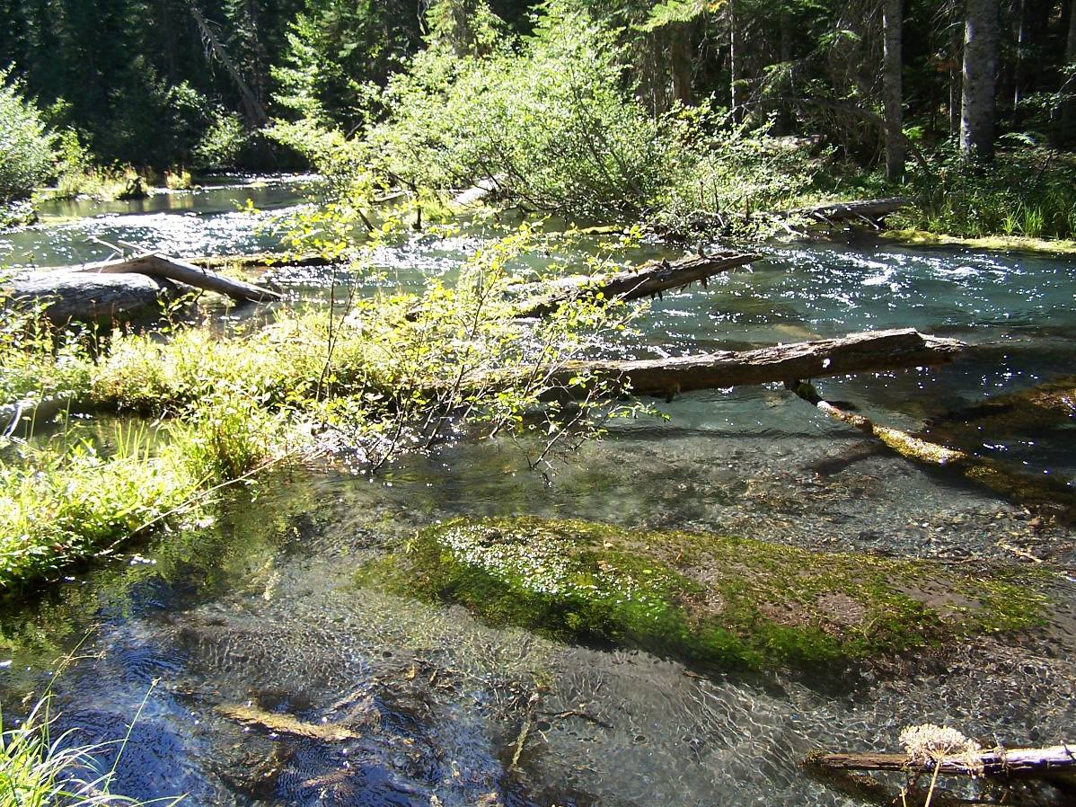

The 4.5 mile hike described below on the High Cascades Ranger District of the Rogue River-Siskiyou National Forest, extends from 4800 ft. to 4000 ft. elevation, without significant stream crossings, and always paralleling, or just above this upper most portion of the Rogue River.

This scenic, partially riverside trail transitions through 14 species of confers, from lodgepole pine, mountain hemlock, Engelmann spruce, and subalpine fir, to mature and old growth forests of Shasta red fir, Pacific silver fir, white fir, grand fir, western hemlock, Douglas fir, western white pine, as well as some sugar pine, ponderosa pine, incense cedar and also Pacific yew.
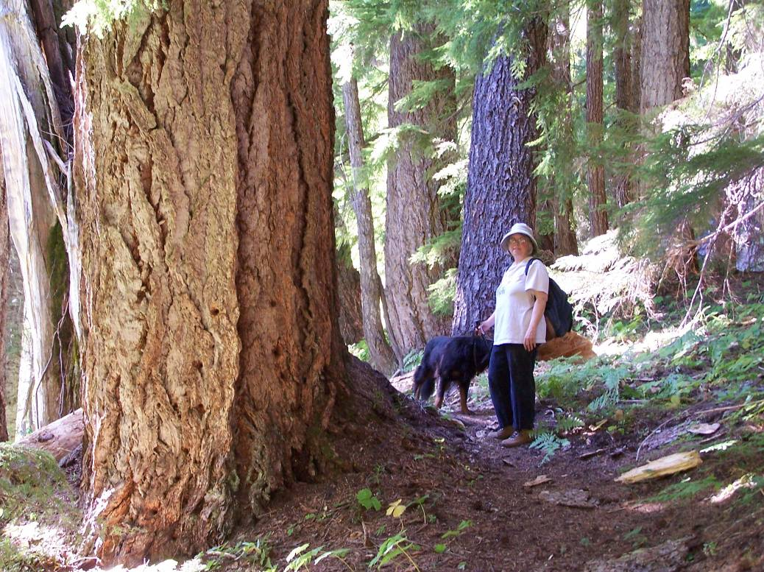

The riparian area is similarly diverse with wildflowers and even the occasional skunk cabbage. After mid-September be on the look out for highly delectable White Chanterelles (Cantharellus subalbidus), Gypsy Mushrooms (Rozites caperata), and most prized growing out of down trees, Conifer Coral Hericium or Bear’s Head (Hericium abietis).

Also, the trail passes by two moderate-sized waterfalls. Additionally, closer to the west end of the trail, one can drop down into a large sphagnum bog meadow that contains western blueberries and interesting herbaceous plants including insectivorous sundews.

General Location:

The principal trailheads (featured here) are off Hwy. 230 at the (orange pole) 16 mile post (Section 31, T28S R 5E), and at the Hamaker Campground turn off just east (uphill) of the 12 mile post. The lower end of Hwy. 230 begins (mile post 0) begins at its western most junction with Hwy. 62, at the turn off for the south entrance to Crater Lake National Park.

Specific Directions:

To do a one way, 4.5 mile, primarily downhill hike, from the Hwy. 138--Diamond Lake junction, drive west on Hwy. 230 (for almost 8 miles) and park along the highway, at the 16 mile post. This is not a “real” trailhead, but a short-cut to the upper portion of the “Upper Rogue River Trail # 1034”. (The best parking place is on the south side of Hwy. 230, 20 yards after (west of) the 16 mile post. Carefully inspect the red cinder shoulder before pulling off, as it can be very soft in some places.) This access, requires an under .2 mile, basically flat, cross county walk, directly south and perpendicular to Hwy. 230. Regardless if you should stray slightly east or west, as long as you head primarily south you can’t miss the trail, which in this stretch, closely parallels the highway, on the very edge of the upper (east-west) Rogue River canyon.

(This suggested cross-country route shortens the 4.5 mile hike by about 2.5 miles along the canyon rim, that actually begins off Hwy. 230 between the 18 and 19 mile post at the “Mt. Mazama Viewpoint”.)

Taking this cross-country “short cut”, pick your way over small down trees, and you will soon come to the trail on the rim of the north side of the Rogue River canyon. At the trail, turn right and follow this initially level path “down stream” to the west.

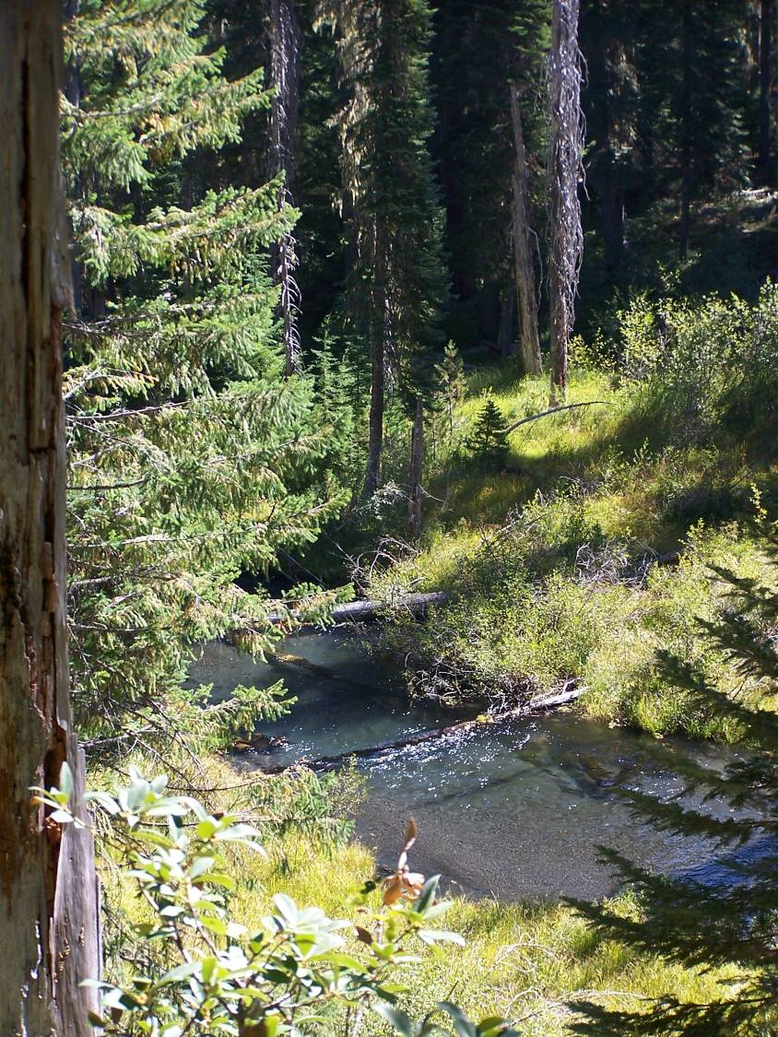

The trail initially follows the canyon rim edge for little over a half mile, before descending (the steepest portion of the 4.5 mile trail hike) to right along side the Rogue River. You will then continue along a streamside, canyon trail. In just under 2 miles from Hwy. 230 you come to the very impressive “Rough Rider Falls”. In another mile you come to a second (unnamed) falls. In another half mile, you can follow a small ravine--downhill and cross-country to a wide basin-like meadow. You’ll then end up at the Rd. 6530 trailhead.
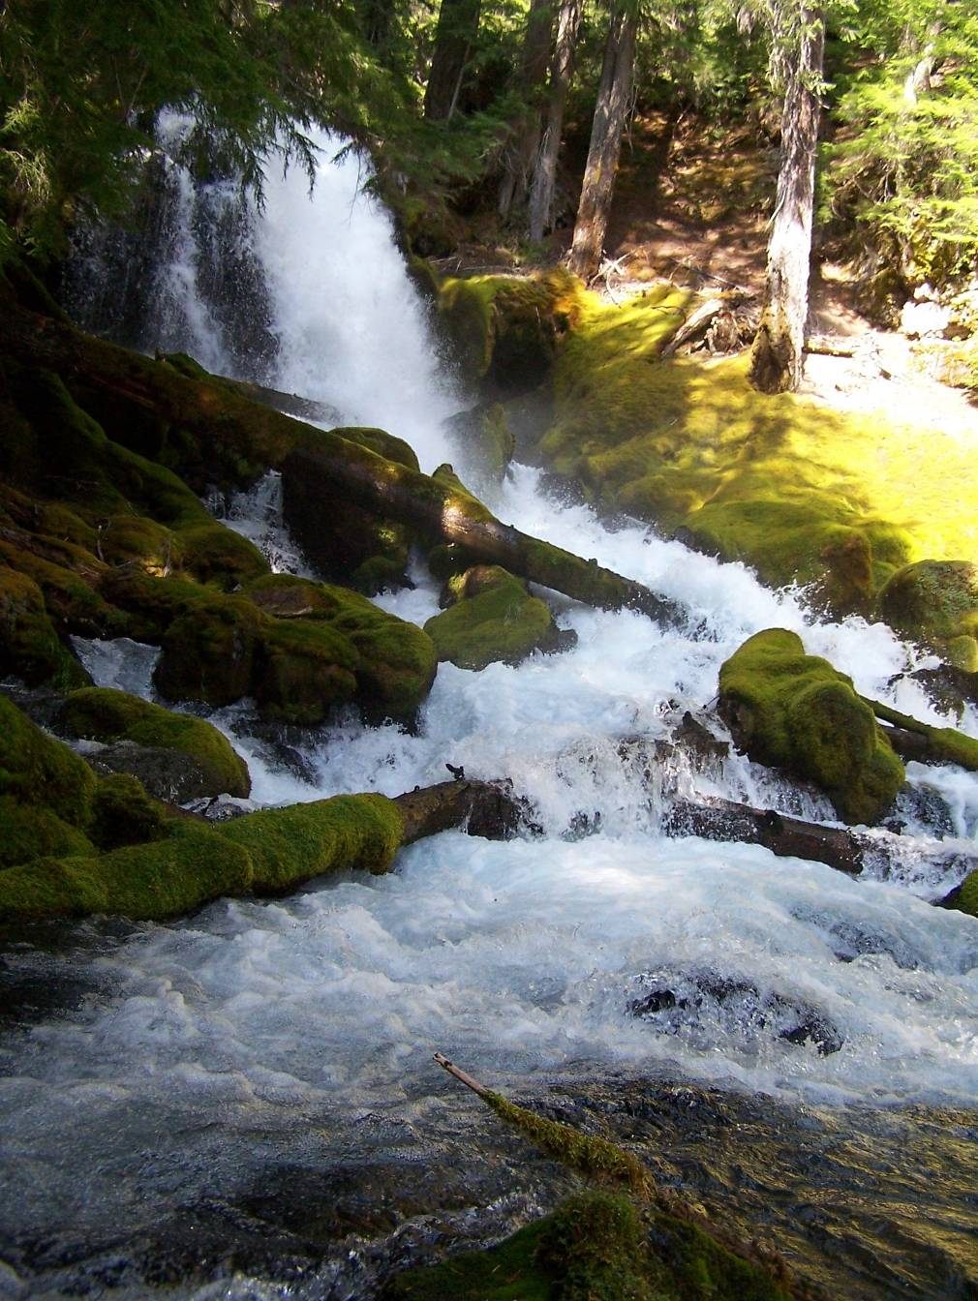
30 foot high Rough Rider Falls has an average, steady year around flow of 250 cfs
Specific Rough Rider Falls Location:
Douglas Co. T28S R 4E Sec. 36
Latitude 43.08608 N
Longitude -122.29045 W
Elevation 4399 feet
USGS Quadrangle Hamaker Butte 7 1/2"

Lower Trailhead and Car Shuttle:

To leave a car at the western most end, take Hwy. 230 (from the junction with Hwy. 138) for almost 12 miles, turning left (south) on FS Rd. 6530 at a sign for “Hamaker Campground”. (This turn off is .2 miles before the 12 mile post that is only visible to drivers coming from west to east, and is opposite FS Rd. 6560.)

Continue south on FS Rd. 6530. In .5 mile bear left, where FS Rd. 900 goes to the right and to the campground. Continue another .3 mile on Rd. 6530 (.8 total from Hwy. 230) and park on your right (before crossing the Rogue River). The “Upper Rogue River Trail #1034” is on the left, directly opposite (on the right) an OHV sign post saying “3” and “54”. Standing at the trailhead a motorcycle trail heads off to the left, where the “Upper Rogue River (hiking) Trail” takes off to the right. There are no vehicles allowed on the hiking trail.

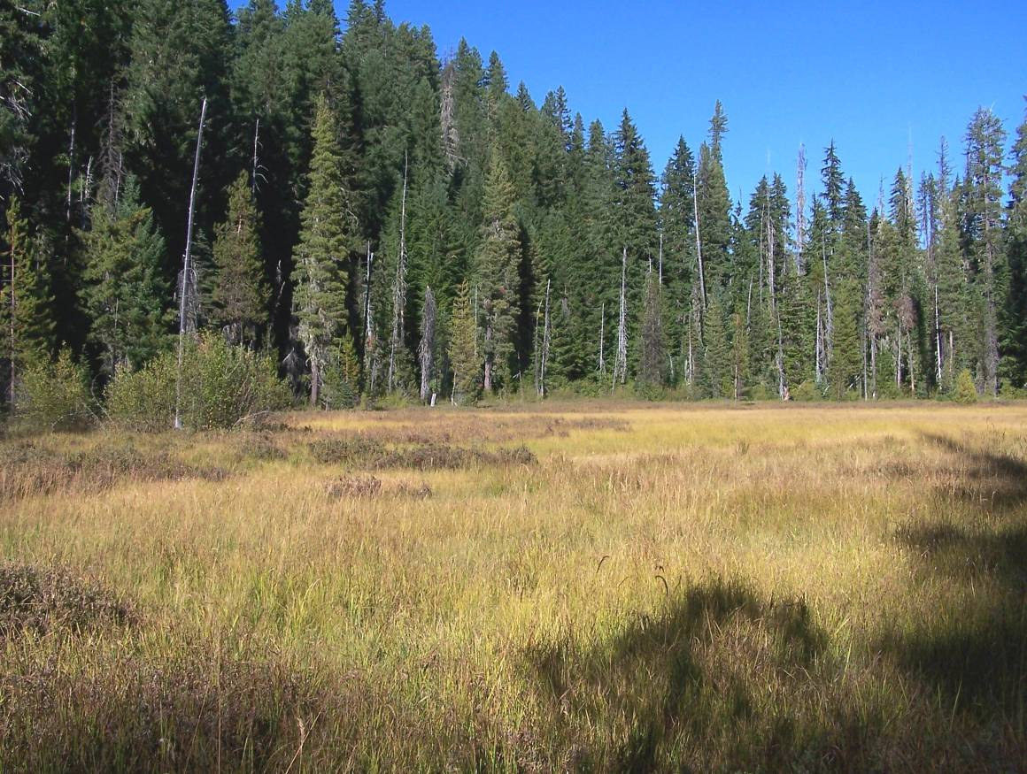
Upper (eastern most) part of unnamed meadow off trail #1034

